Homology-Aware Gene-Level Split Analysis
This report presents the results of a homology-aware gene-level data split designed to eliminate sequence similarity bias between training and test sets. Promoter sequences were clustered using CD-HIT-EST at 80% sequence identity, and entire clusters were assigned to either training or test sets, ensuring that no homologous genes appear in both.

1. Executive Summary
Metric | Value | Interpretation
CARCM AUC (Homology) | 0.7199 | Robust performance on unseen gene families
Random Split AUC | 0.8522 | Previous evaluation with potential data leakage
ΔAUC (Random − Homology) | 0.1323 | Performance drop attributable to sequence similarity
Context ΔAUC | +0.1799 | Context improvement persists under strict split

2. Methods

2.1 Sequence Clustering
Promoter sequences (1000 bp upstream of TSS) were extracted for each unique gene and clustered using CD-HIT-EST with 80% sequence identity threshold (word size = 5). This groups homologous promoters that share significant sequence similarity.

2.2 Cluster-Level Split
Entire clusters were assigned to train (70%), dev (10%), or test (20%) partitions. Assignment was stratified by the majority variety and class label distribution within each cluster to preserve biological diversity across splits. Critically, no gene (and therefore no homologous sequence) appears in more than one partition.

2.3 Split Statistics
split | n_samples | n_genes | n_clusters | pct_up | n_varieties | n_tissues | n_stages
train | 31126 | 11932 | 11821 | 53.3 | 13 | 8 | 6
dev | 4545 | 1711 | 1688 | 53.0 | 13 | 8 | 6
test | 8831 | 3399 | 3366 | 53.3 | 13 | 8 | 6

3. Results

3.1 Model Performance on Homology-Aware Split
Model | AUC | PR-AUC | F1 | MCC | Balanced_Acc
CARCM (full) | 0.7199 | 0.7634 | 0.6616 | 0.3007 | 0.6507
Seq-only (context zeroed) | 0.5399 | 0.5777 | 0.4912 | 0.0532 | 0.5262
Seq-only LogReg | 0.5395 | 0.5813 | 0.5893 | 0.0455 | 0.5222

3.2 Statistical Significance
- CARCM vs SeqOnly zeroed: p = 0.000000 (significant)
- CARCM vs SeqOnly LogReg: p = 0.000000 (significant)

3.3 Comparison: Random vs Homology-Aware Split
The CARCM model achieved an AUC of 0.8522 on the random 80/10/10 split and 0.7199 on the homology-aware split, representing a drop of 0.1323. This is expected: the random split allows homologous sequences (with highly similar motif profiles) to appear in both training and test sets, inflating apparent performance.
The context ablation ΔAUC on the homology-aware split is +0.1799 (CARCM vs sequence-only with zeroed context), confirming that biological context (variety, tissue, stage) contributes genuine predictive signal even when sequence similarity bias is removed.

4. Figures
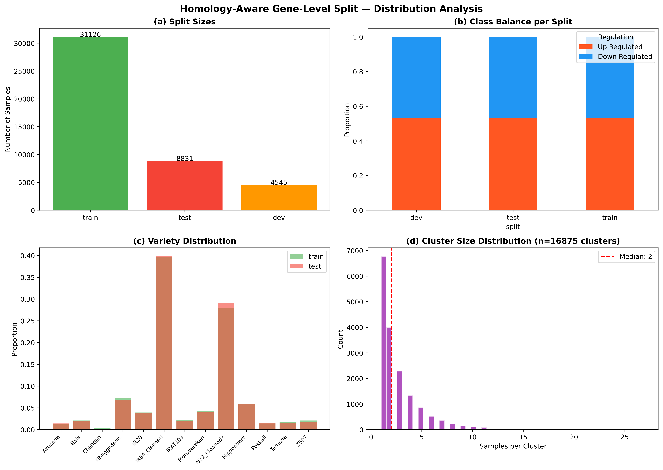
Figure: Split Distribution
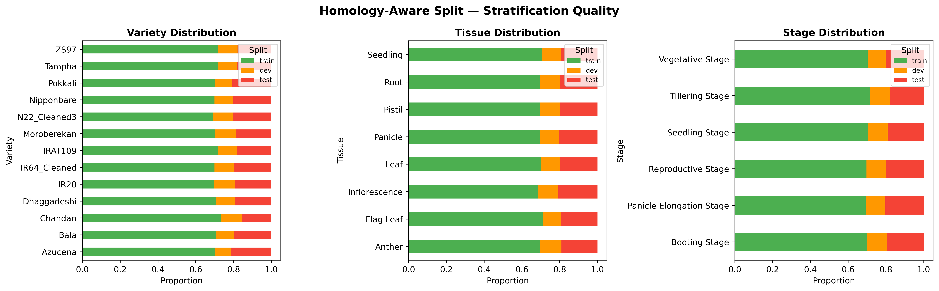
Figure: Split Quality
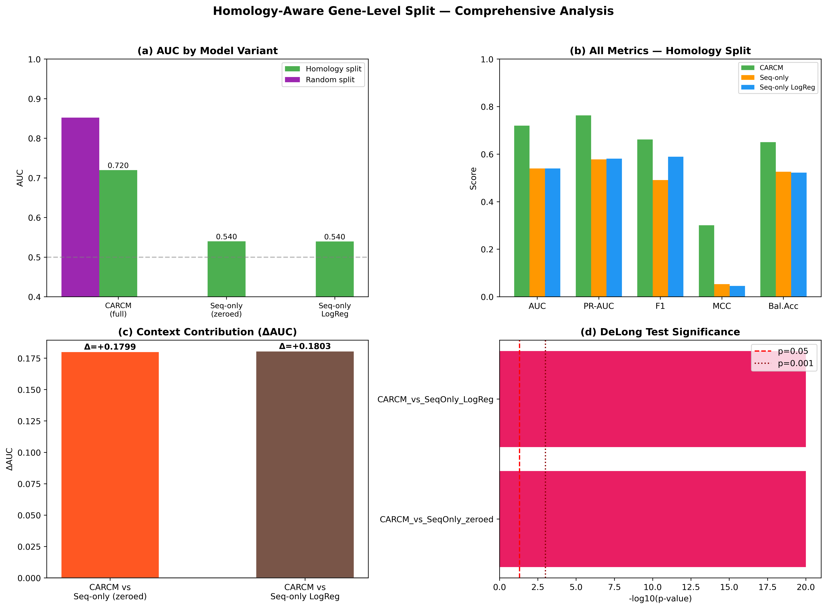
Figure: Homology Split Analysis
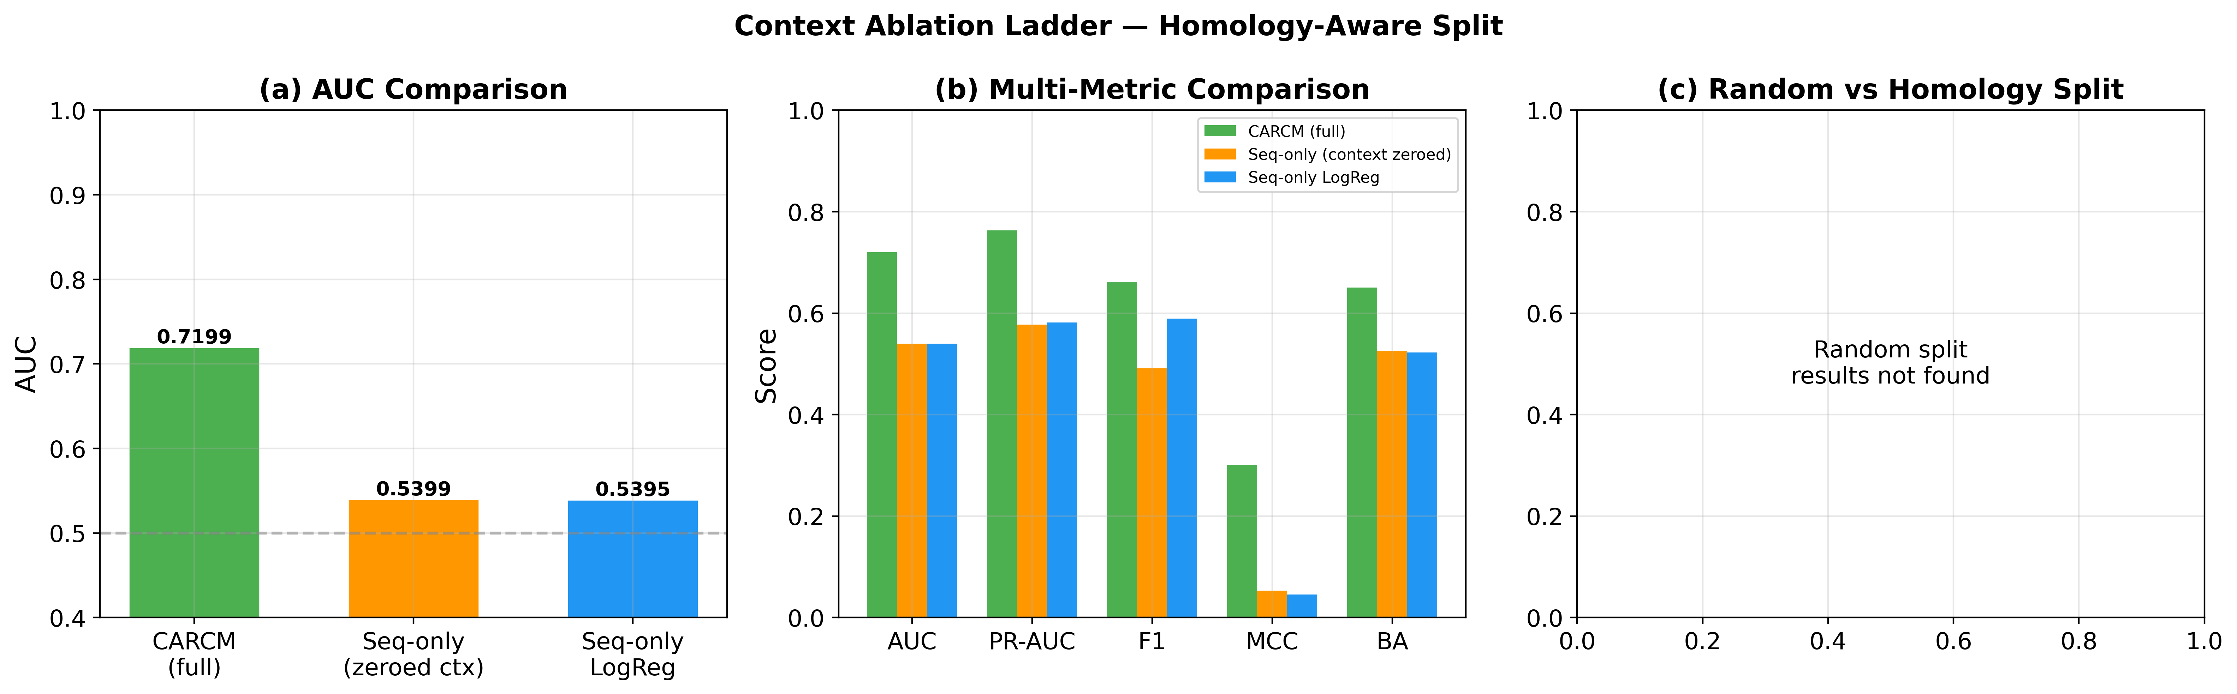
Figure: Ablation Ladder

5. Conclusion
The homology-aware split reveals a substantial AUC drop to 0.7199 (from 0.8522), suggesting that sequence similarity between train and test sets contributed meaningfully to the random-split performance.
The context ablation ladder on the homology-aware split shows CARCM AUC (0.7199) > Sequence-only (0.5399), with ΔAUC = +0.1799, confirming that context features provide genuine biological signal beyond what can be captured by sequence motifs alone. This result holds even under the strictest split regime, strengthening the manuscript's central claim that variety, tissue, and developmental stage modulate drought-responsive gene regulation.

6. Implications for the Manuscript
- 1. The homology-aware split should be reported as a supplementary validation to address reviewer concerns about data leakage.
- 2. The AUC drop from random to homology split quantifies the "similarity bonus" and demonstrates transparency.
- 3. The persistent context ΔAUC on the homology-aware split directly supports sub-claim C: context carries real biological signal for drought-response prediction.

